**“Screenshots”**

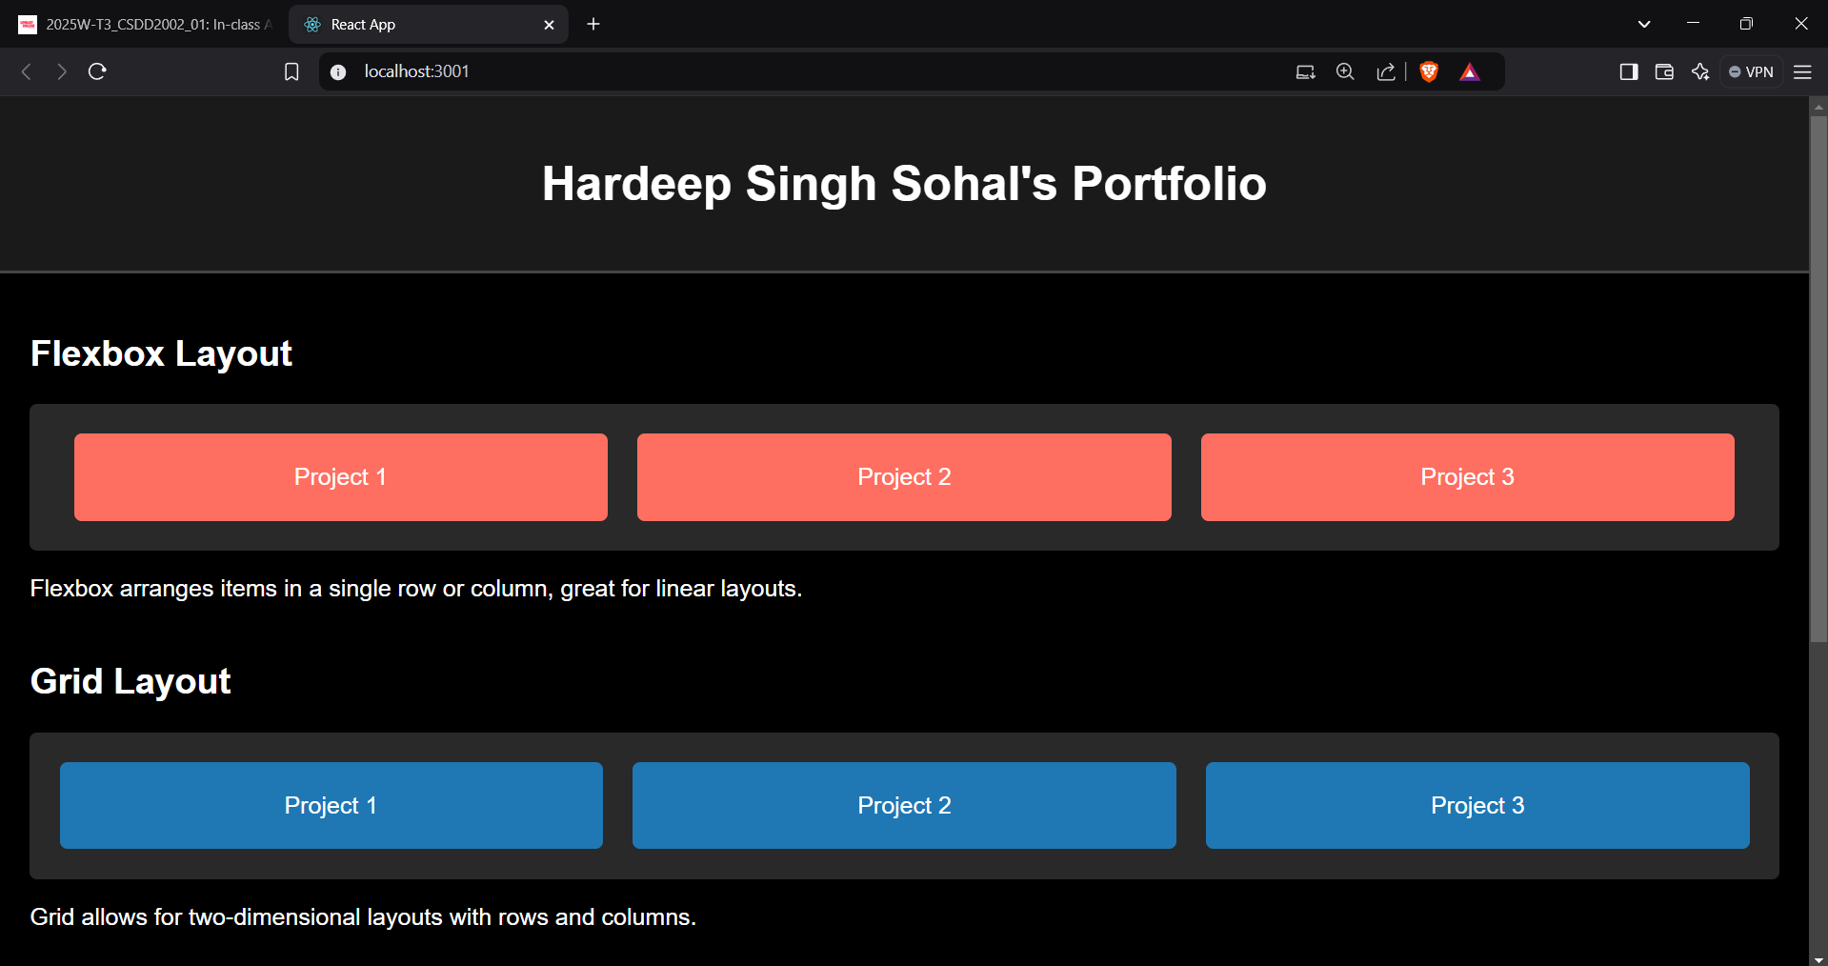



**React Code:**

**FlexSection.js:**

import React from "react";

const FlexSection = () => {

  return (

    <section className="flexbox-demo">

      <h2>Flexbox Layout</h2>

      <div className="flex-container">

        <div className="flex-item">Project 1</div>

        <div className="flex-item">Project 2</div>

        <div className="flex-item">Project 3</div>

      </div>

      <p className="note">Flexbox arranges items in a single row or column, great for linear layouts.</p>

    </section>

  );

};

export default FlexSection;

**GridSection.js:**

import React from "react";

const GridSection = () => {

  return (

    <section className="grid-demo">

      <h2>Grid Layout</h2>

      <div className="grid-container">

        <div className="grid-item">Project 1</div>

        <div className="grid-item">Project 2</div>

        <div className="grid-item">Project 3</div>

      </div>

      <p className="note">Grid allows for two-dimensional layouts with rows and columns.</p>

    </section>

  );

};

export default GridSection;

**Contact.js:**

import React from "react";

const Contact = () => {

  return (

    <footer className="contact">

      <h2>Contact Information</h2>

      <p>Name: Hardeep Singh Sohal</p>

      <p>Course: CSSD (Computer Software Database Development)</p>

      <p>College: Loyalist College, Toronto</p>

      <p>Address: 8 Summer Dr, Scarborough, Ontario</p>

      <p>Passion: Graphics Designer, Artist, Gamer</p>

      <p>Email: hardeepsohal786@gmail.com</p>

      <p>Instagram: @mysticsoul786_</p>

    </footer>

  );

};

export default Contact;

**App.js:**

import React from "react";

import "./App.css";

import FlexSection from "./components/FlexSection";

import GridSection from "./components/GridSection";

import Contact from "./components/Contact";

function App() {

  return (

    <div className="App">

      <header>

        <h1>Hardeep Singh Sohal's Portfolio</h1>

      </header>

      <main>

        <FlexSection />

        <GridSection />

      </main>

      <Contact />

    </div>

  );

}

export default App;

**App.css:**

body {

  font-family: Arial, sans-serif;

  margin: 0;

  padding: 0;

  background-color: black;

  color: white;

}

header {

  background-color: #1a1a1a;

  text-align: center;

  padding: 20px 0;

  border-bottom: 2px solid #444;

}

h1, h2 {

  margin: 20px 0;

}

main {

  padding: 20px;

}

/* Flexbox Section */

.flexbox-demo {

  margin-bottom: 40px;

}

.flex-container {

  display: flex;

  justify-content: space-around;

  align-items: center;

  background-color: #292929;

  padding: 20px;

  border-radius: 5px;

}

.flex-item {

  background-color: #ff6f61;

  color: white;

  text-align: center;

  padding: 20px;

  margin: 0 10px;

  border-radius: 5px;

  flex: 1;

}

/* Grid Section */

.grid-demo {

  margin-bottom: 40px;

}

.grid-container {

  display: grid;

  grid-template-columns: repeat(3, 1fr);

  gap: 20px;

  background-color: #292929;

  padding: 20px;

  border-radius: 5px;

}

.grid-item {

  background-color: #1f78b4;

  color: white;

  text-align: center;

  padding: 20px;

  border-radius: 5px;

}

/* Contact Section */

.contact {

  background-color: #1a1a1a;

  padding: 20px;

  text-align: center;

  margin-top: 40px;

  border-top: 2px solid #444;

}

.contact p {

  margin: 5px 0;

  color: #b3b3b3;

}